CONTENTS

1. Introduction 3

2. Explanation of eCRM 3

eCRM Office 3

3. About eCRM 4

3.1 Independence Apps 4

3.2 Web Apps 4

3.3 eCRM Field (eCRM Field,eVRSCal,Single Base) 4

3.4 eCRM Office (Office, Manual, Single Base) 4

3.5 GNSS Calibration 5

4.Application Architecture and Design 7

4.0 Platforms used & Open Sources products used 7

4.1 eVRSCal 7

4.2 eCRM Field 7

4.3 Single Base 7

4.4 eCRM Office 8

4.5 GNSS Calibration 8

4.6 Applications/Component for eCRM 8

5. Data Structure and Design 9

5.0 Folder Structure 9

5.1 eCRM Field 10

5.2 eCRM Office 10

6. Installation and Configuration 12

6.1 eCRM Office 12

6.1.1 Postgres 12

6.1.2 Application Server & Geoserver 13

6.1.3 .Net Core & Framework 14

6.1.4 eCRM Office Main Folder 15

6.1.5 Windows Schedular and Services 18

6.1.6 Integration & Webservices 19

6.1.7 Servers IP & Hostname and Credentials 19

6.1.8 Remote Access 19

6.2 eCRM Field 19

6.2.1 Trimble SDK 19

6.2.2 GDAL 19

6.2.3.Net Framework 19

6.2.4 eCRM Field & License 19

6.2.5 Integration & Webservices 19

7. Application Workflow 20

7.1 eVRSCal 20

7.2 eCRM Field 20

7.3 Single Base 20

7.4 eCRM Office 21

eCRM Office Workflow 22

Automatic Uploading Workflow 23

Computation Workflow 23

eCosting Workflow 25

7.5 GNSS Calibration 26

# 1. Introduction

# 2. Explanation of eCRM

## eCRM Office

eCRM Office suite is an web application dedicated to help calculate the coordinate values by comparing results taken from Trimble devices and those that were obtained by SpidernetRTK.

eCRM Office serves 3 main purpose:

1. To verify if the job file is observed correctly and in accordance to the rules set by JUPEM.
2. Calculates and provides an avenue for users to analyze the computation made on the website itself.
3. Generates the required files for further analysis and documentation purposes.

The system uploads the zipped job file, organizes the information that was stored in the zipped file and displays it in the website for the user to view. The information that is display are:

1. Filename and the number of points in the file
2. Map of the eCRM points
3. Files obtained from eCRM Field:
   1. RTGA file (if RTK reading was done)
   2. eVRSCAL cert and verification
4. Files obtained post-processing
   1. Computation steps
   2. Baseline Processing reports
   3. PVM Report (Only if all points are passed)
5. Images captured during the observations
6. Documents recorded during the observations
7. Breakdown of each points and methods of observation
8. RINEX log for all points
9. Status of processing of each file
10. Activity logs
11. FAQ page
12. Statistical summary page

eCRM Office serves as a stop point to allow the users to process the points automatically and analyze the output results. There is a manual option should the user wished to calculate the point verification themselves, whereby the system will compute the readings but will not compare it with any Virtual RINEX values.

Once completed, users can download the said job file, with updated .POT points and submit it to JUPEM2U webservice for further analysis and update the values accordingly.

# 3. About eCRM

## 3.1 Independence Apps

## 3.2 Web Apps

## 3.3 eCRM Field (eCRM Field,eVRSCal,Single Base)

## 3.4 eCRM Office (Office, Manual, Single Base)

|  |  |
| --- | --- |
| PLATFORM | DESCRIPTION |
| Office Web Application | 1. Serves as the main interface 2. Allows viewing of job file content in the website itself. 3. Able to see number of files in-hand, passed, failed and those that are still in-processing 4. For the KC, they’re able to view all of the users and their reports contain all those under his department. 5. Generates:  * PVM reports * Baseline report * RINEX Log report * Computation Steps report |
| Automatic Processing | 1. Uploads the Job File into the server 2. Checks for:  * Improper file zip * Tampered files * Incomplete observation * Conflicting Rover and POT entries * Naming convention of the job file  1. Starts the processing of the job files |
| Manual Processing | 1. Uploads the Job File into the server 2. Checks for:  * Ecrm2.json * Manual folder * DC files * VCE files  1. Updates GDPM_SESS column from ‘Auto’ to ‘Manual’ |
| Single Base Processing | 1. Starts the Single Base uploading and checks 2. Searches for:  * Sessions.json * GDSMSBPROJECTS folder  1. Applicable for Labuan for now |

## 3.5 GNSS Calibration

|  |  |
| --- | --- |
| PLATFORM | DESCRIPTION |
| GNSS Web Application | 1. Serves as the main interface 2. Allows viewing of job file content in the website itself. 3. Able to see number of files in-hand, passed, failed and those that are still in-processing 4. For the KC, they’re able to view all of the users and their reports contain all those under his department. 5. Generates:  * Baseline report * RINEX Log report * Computation Steps report * Vrscal.json |
| Automatic Processing | 1. Uploads the Job File into the server 2. Checks for:  * Improper file zip * Tampered files * Incomplete observation * Conflicting Rover and POT entries * Naming convention of the job file   Starts the processing of the job files |
| Manual Processing | 1. Uploads the Job File into the server 2. Checks for:  * Ecrm2.json * Manual folder * DC files * VCE files   Updates GDPM_SESS column from ‘Auto’ to ‘Manual’ |
| Single Base Processing |  |

# 4.Application Architecture and Design

## 4.0 Platforms used & Open Sources products used

|  |  |
| --- | --- |
| PLATFORM | DESCRIPTION |
| Office Web Application | * Front-End:  1. SMILE Theme Admin Template 2. JQuery (Ver 3.2.1) 3. Dropzone.js (Ver 5.0.x) 4. Lightbox (Ver 2.10.0) 5. EasyTimer.js (Ver 3.2.0)  * Back End:  1. .Net Core SDK 2.1 2. .Net Framework 4.7.1 3. Asp.NET MVC |
| Open Source Products | * PostgreSQL 10 * PgAdmin 4.X (Only when it’s prompted) * TrimbleCFGUpdate.exe (Latest if available) * GDAL-202.msi * GDAL-204.msi * TrimbleOpticalCFGUpdate_v17.8.9.msi * ConvertToRinex.msi (Version 3.0.6 and above) |

## 4.1 eVRSCal

## 4.2 eCRM Field

## 4.3 Single Base

## 4.4 eCRM Office

|  |  |
| --- | --- |
| PLATFORM | DESCRIPTION |
| Office Web Application | * Front-End:  1. SMILE Theme Admin Template 2. JQuery (Ver 3.2.1) 3. Dropzone.js (Ver 5.0.x) 4. Lightbox (Ver 2.10.0) 5. EasyTimer.js (Ver 3.2.0)  * Back End:  1. .Net Core SDK 2.1 2. .Net Framework 4.7.1 3. Asp.NET MVC |
| Open Source Products | * PostgreSQL 10 * PgAdmin 4.X (Only when it’s prompted) * TrimbleCFGUpdate.exe (Latest if available) * GDAL-202.msi * GDAL-204.msi * TrimbleOpticalCFGUpdate_v17.8.9.msi * ConvertToRinex.msi (Version 3.0.6 and above) |

## 4.5 GNSS Calibration

Same as requirement as in eCRM Office

## 4.6 Applications/Component for eCRM

# 5. Data Structure and Design

## 5.0 Folder Structure

For Office application, the Folder structure is divided into two; Report and Baseline are located in the C: drive, while GDPM, Map, eCRM and GNSS folder are located in the second drive (D: drive or E: drive).

Figure 5.1: The Folder structure in C: Drive that holds the Report and Baseline folder

Figure 5.2: The Folder structure in the other drive that holds the Office folders

## 5.1 eCRM Field

## 5.2 eCRM Office

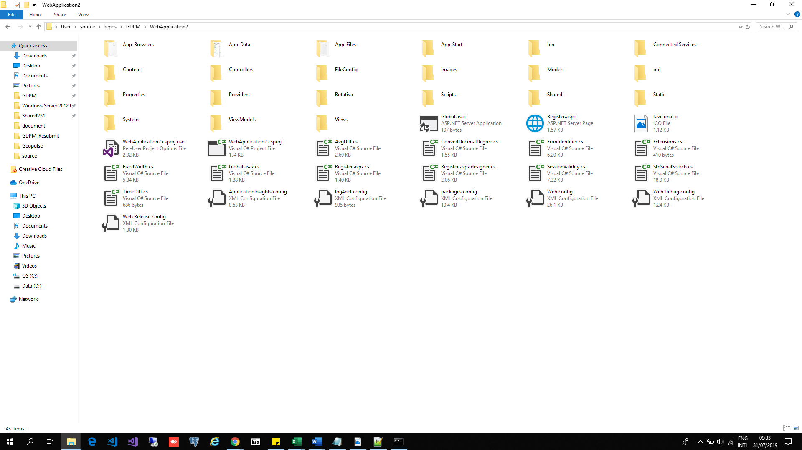

Figure 5.4.1: eCRM Office folder structure

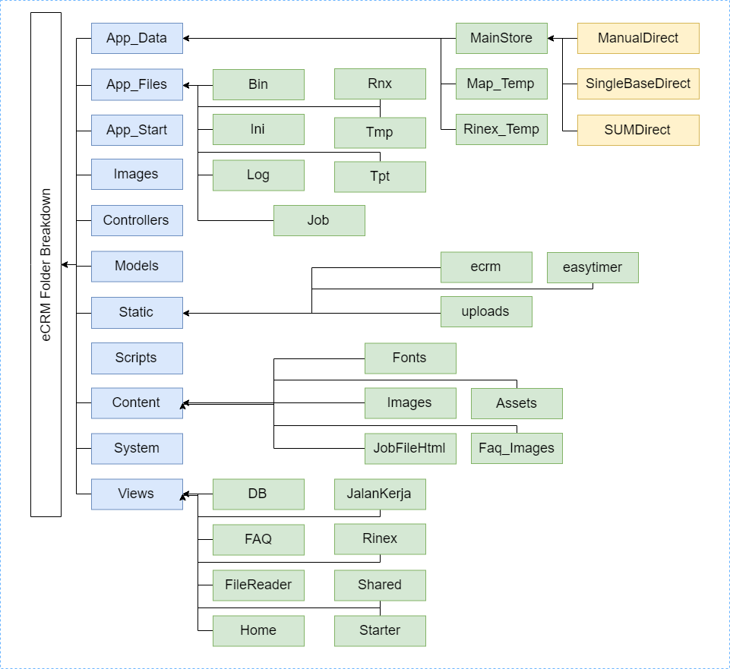

Figure 5.4.2: The breakdown of the major folders. Full list is provided in the Index

These are the major folders that are important in the web application that must sit in the server. The table details the functions of each table and its content.

|  |  |  |
| --- | --- | --- |
| MAIN FOLDER | SUB FOLDER |  |
| Office Web Application | * Front-End:  1. SMILE Theme Admin Template 2. JQuery (Ver 3.2.1) 3. Dropzone.js (Ver 5.0.x) 4. Lightbox (Ver 2.10.0) 5. EasyTimer.js (Ver 3.2.0)  * Back End:  1. .Net Core SDK 2.1 2. .Net Framework 4.7.1 3. Asp.NET MVC |  |
| Open Source Products | * PostgreSQL 10 * PgAdmin 4.X (Only when it’s prompted) * TrimbleCFGUpdate.exe (Latest if available) * GDAL-202.msi * GDAL-204.msi * TrimbleOpticalCFGUpdate_v17.8.9.msi * ConvertToRinex.msi (Version 3.0.6 and above) |  |

# 6. Installation and Configuration

## 6.1 eCRM Office

### 6.1.1 Postgres

#### 6.1.1.1 UML Diagram

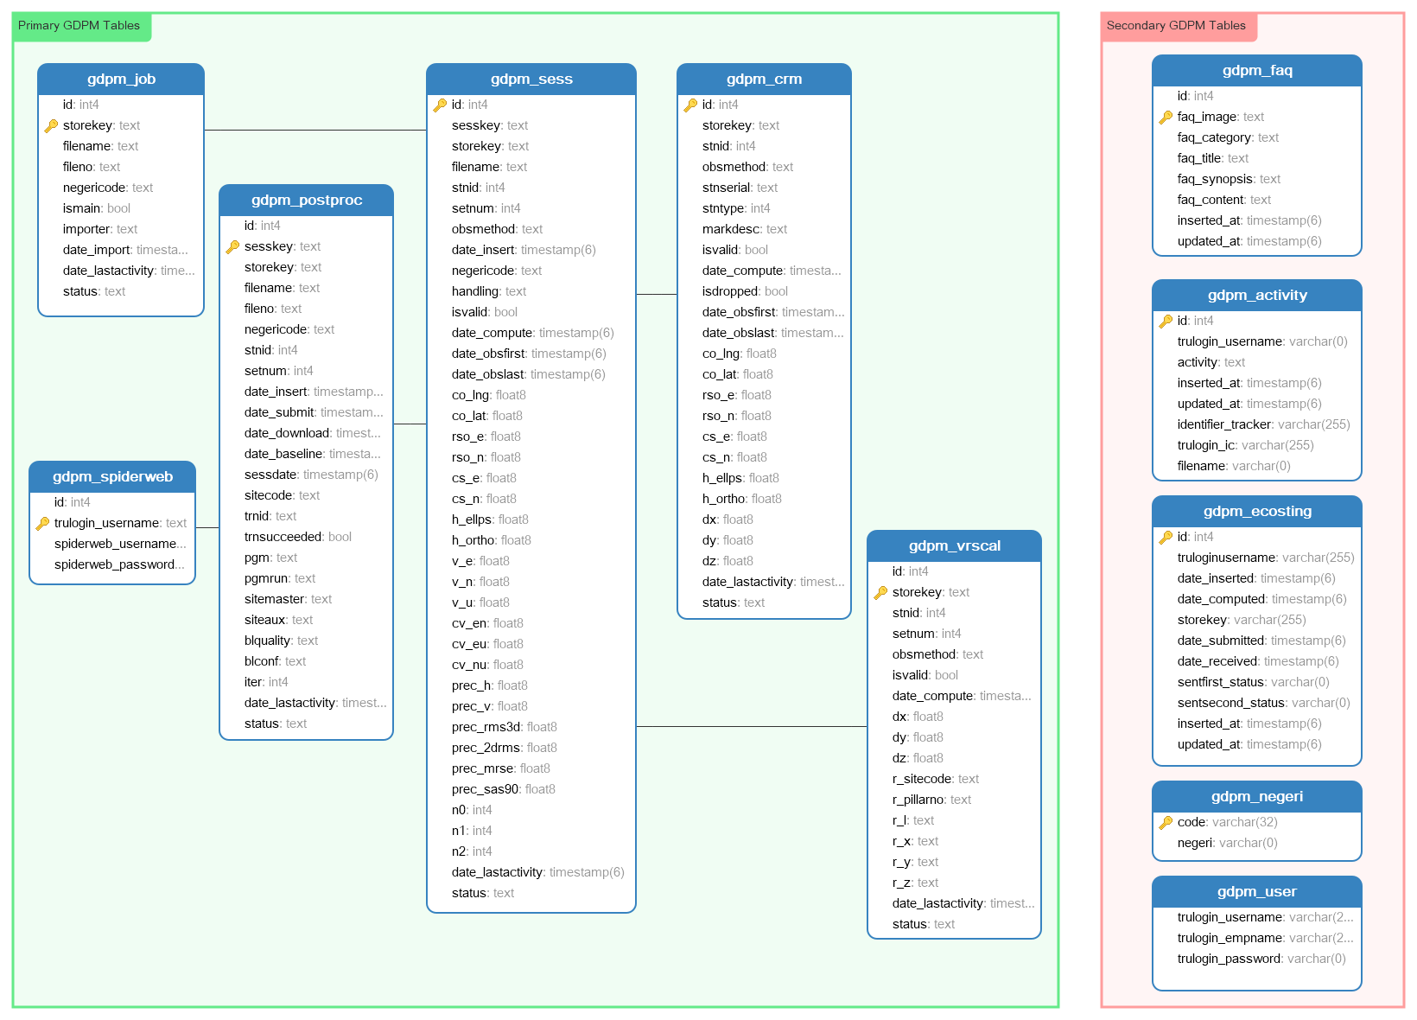

#### 6.1.1.2 Installation Guide

* + - 1. Download PostgreSQL from <https://www.enterprisedb.com/downloads/postgres-postgresql-downloads>
      2. Select version 10.XX
      3. Once download is complete, click on the application to start installation:
         1. Username: postgresql
         2. Password:

Development: 123pass / root

Production: postgres456

* + - 1. Click on PgAdmin to open the Postgresql panel
      2. Right-click on Database and create “ecrm” database
      3. Click down until you reach ‘Tables’ and right-click and select Restore.
      4. Browse to where the ecrm.SQL is located and restore from it
      5. In the event for backup:
         1. Follow the steps
         2. Right-click and select ‘Backup’
         3. Export as a .tar file

### 6.1.2 Application Server & Geoserver

#### 6.1.2.1 Application Server List

|  |  |
| --- | --- |
| **Application Server** | **Function** |
| GDPM_Server | Location:   * GDPM_Store   Functionality:   * Start server * Import file (upload to DB) * Export file (download to user) * Delete file |
| GDPM_Postproc | Location:   * GDPM_Spider   Functionality:   * Send sessions of observed points * Retrieve those said sessions * Resubmit sessions * Purge sessions in the SpiderwebRTK |
| GDPM_Compute | Location:   * GDPM_Compute   Functionality:   * Compute baseline * Compute sessions and points projected coordinates |
| GDPM_Ecosting | Location:   * GDPM_Ecosting   Functionality:   * Send first record of the amount of time take to be uploaded and submitted to Spiderweb * Send second set of records of the amount of time taken to be retrieved and computed |

#### 6.1.2.2 Setting up the GDPM files

1. Go to the AppFile subdirectory in the eCRM folder
2. Go to the INI folder
3. Locate eCRMOffice.json
4. Change these settings:
   1. DBStore: The current username and password of the PostgrSQL
   2. ConvertToRInex:
      1. If changed to a folder, update the link. Else leave the default link
      2. Test the link to see if the ConvertToRinex file is in that directory
   3. WindowStuck: The value must always be 480

*Compute: For Labuan, RSO must be BRSO

### 6.1.3 .Net Core & Framework

#### 6.1.3.1 Application List

|  |  |
| --- | --- |
| **Files Required** | **Link** |
| DotNetSdk – 2.1.302-X64.exe  * Latest Version is acceptable as well | <https://dotnet.microsoft.com/download/dotnet-core/2.1> |
| DotNet Framework 4.7.1 | <https://www.microsoft.com/en-us/download/details.aspx?id=56116> |
| Gdal-202-1911-x64.msi | * Provided by Geopulse |
| Gdal-204-1911-x64.msi | * Provided by Geopulse |
| TrimbleCFGUpdate.exe  * Download the latest version | <https://www.trimble.com/Monitoring-Solutions/trimbleconfiguration_ts.aspx> |
| TrimbleCFGUpdate_V18.5.10.msi |  |
| TrimbleOpticalCFGUpdate_V17.8.9.msi |  |
| ConvertToRinex3.0.9.msi  * Install CFGUpdate first | <https://www.trimble.com/support_trl.aspx?Nav=Collection-40773&pt=Trimble%20RINEX> |

#### 6.1.3.2 Installation Steps

* + - 1. Install DotNetSDK and DotNet Framework first
      2. Install bothe the GDALs
      3. Download the latest TrimbleCFGUpdate version and install it
      4. Install the TrimbleOpticalCFGUpdate
      5. Finally install the ConvertToRinex:
         1. After installation, test with a .T02 file to check that the application works
         2. If it fails, try installation with higher versions I.e. ConvertToRinex3.0.12.
         3. If it still has issues, then go to lower versions, as long as it is version 3

### 6.1.4 eCRM Office Main Folder

#### 6.1.4.1 Overview of the Office folders

|  |  |
| --- | --- |
| **Folders Required** | **Content** |
| eCRM folder | Contains the components of the web application for eKadastral Reference Mark |
| GNSS Folder | Contains the components of the web application for GNSS |
| Report Folder | Contains the components to generate the required PVM report |
| Baseline Folder | Contains the Components to generate the Baseline Reports |

##### PART A: Folders setting on C: Drive

1. Search for “inetpub” folder.
2. Click to enter “wwwroot”.
3. Place “report.zip” and “baseline.zip” into the folder and extract the files.
4. Return to the “inetpub” folder and right-clibk on “wwwroot””
5. Go to Properties and search for the “Securities” tab.
6. Click on “Edit”
7. Click on Add to add “IIU_IUSRS” if it’s not available. Tick on all of the checkboxes except for “Full Control”

##### PART B: Folder setting on D: Drive or E: Drive

1. Create a folder named “inetpub”.
2. Create a folder titled “wwwroot” inside the “inetpub” folder
3. Place the GDPM folder in the “inetpub” folder.
4. Inside the “wwwroot” folder, create two folders:
   1. ecrm – for eCRM files
   2. gnss – for GNSS files
5. Place all the eCRM office file content into the ecrm folder

#### 6.1.4.2 Setting of Office files

1. Go to the eCRM folder
2. Search for Web.Config
3. Scroll to the line <application setting>:
   1. For PathImage, PathFiles: Change it to the hostname of the website/url

Example: <http://office.jupem.xxx.gov.my/ecrm>

* 1. For PathJupem: “office.jupem.xxx.gov.my/ecrm” (DO NOT INCLUDE http://).
  2. For PathMap: <http://office.jupem.xxx.gov.my:5000>
  3. Trulogin: eKadastar url
  4. PathDate: the eCRM AppFiles folder link
  5. Ensure that NoSessionTesting is set to ‘TRUE’ to make sure only logged in User can enter the eCRM system.

1. If using the latest template, in the AppFiles > Ini folder, search for Officesetting.json:
   1. The setting for PathImage, PathFiles, PathJupem, PathMap is as above
   2. Path should be remapped to search for OfficeSetting.json.

#### 6.1.4.3 Setting for Map

1. Locate the map_temp folder under AppData folder and save the directory link.
2. Place the “CRM_Srv” in the “inetpub” folder
3. Open the said folder and locate “appsetting.json”
4. At BasePath, update the link to the current directory link.
5. To test is on the right path:
   1. On the address bar, type “cmd.exe” to run the Command Line on that folder.
   2. Go to <http://localhost:5000> to view the map

(DO NOT CTRL+C else it’ll shut down the server)

#### 

#### 6.1.4.4 Application Pool for both Office and Map in Inetmgr

1. Windows Button + R to open the R command and type “inetmgr”.

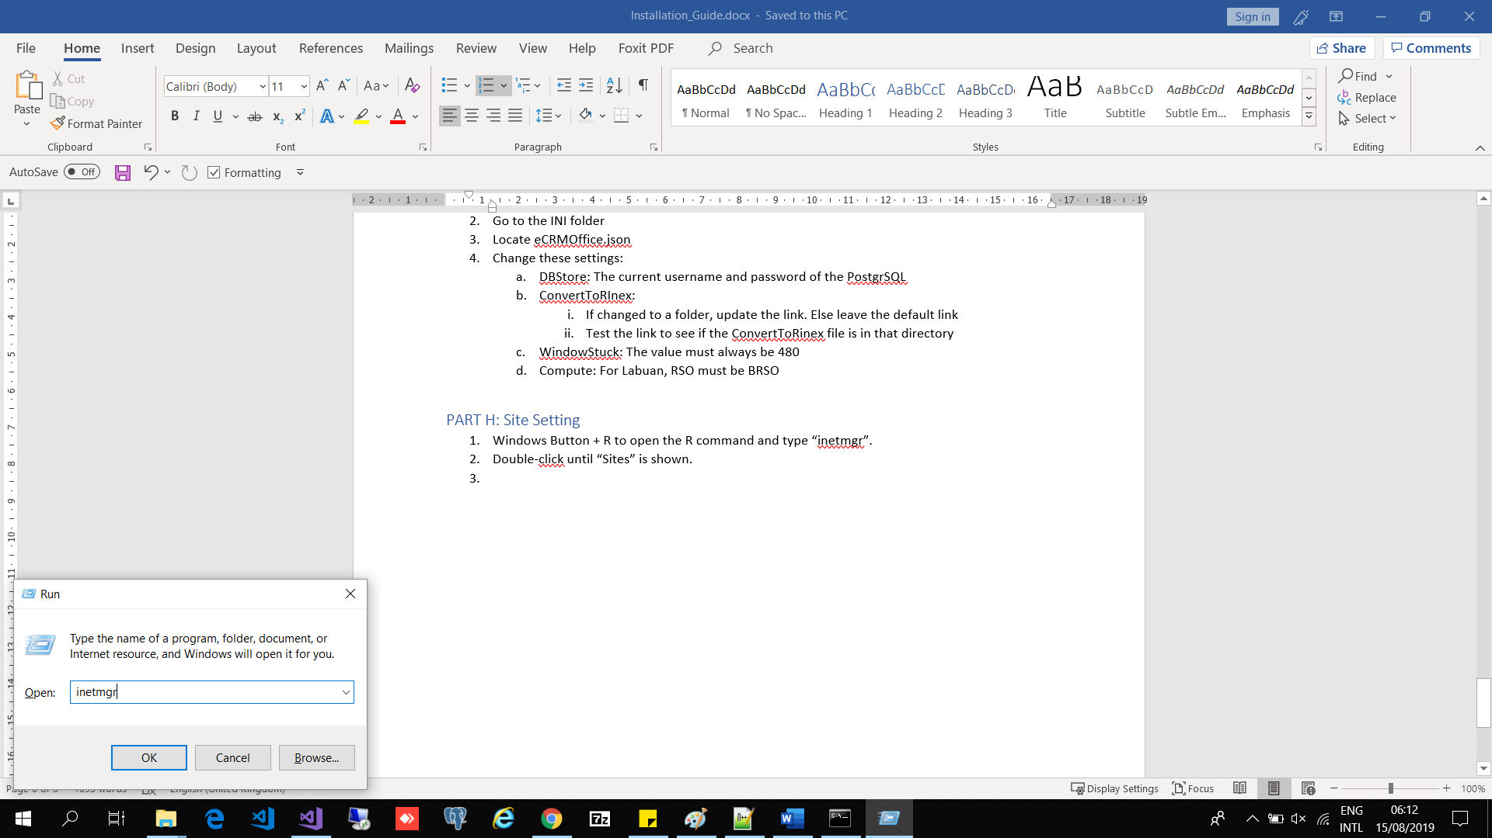

1. Double-click until “Sites” is shown.

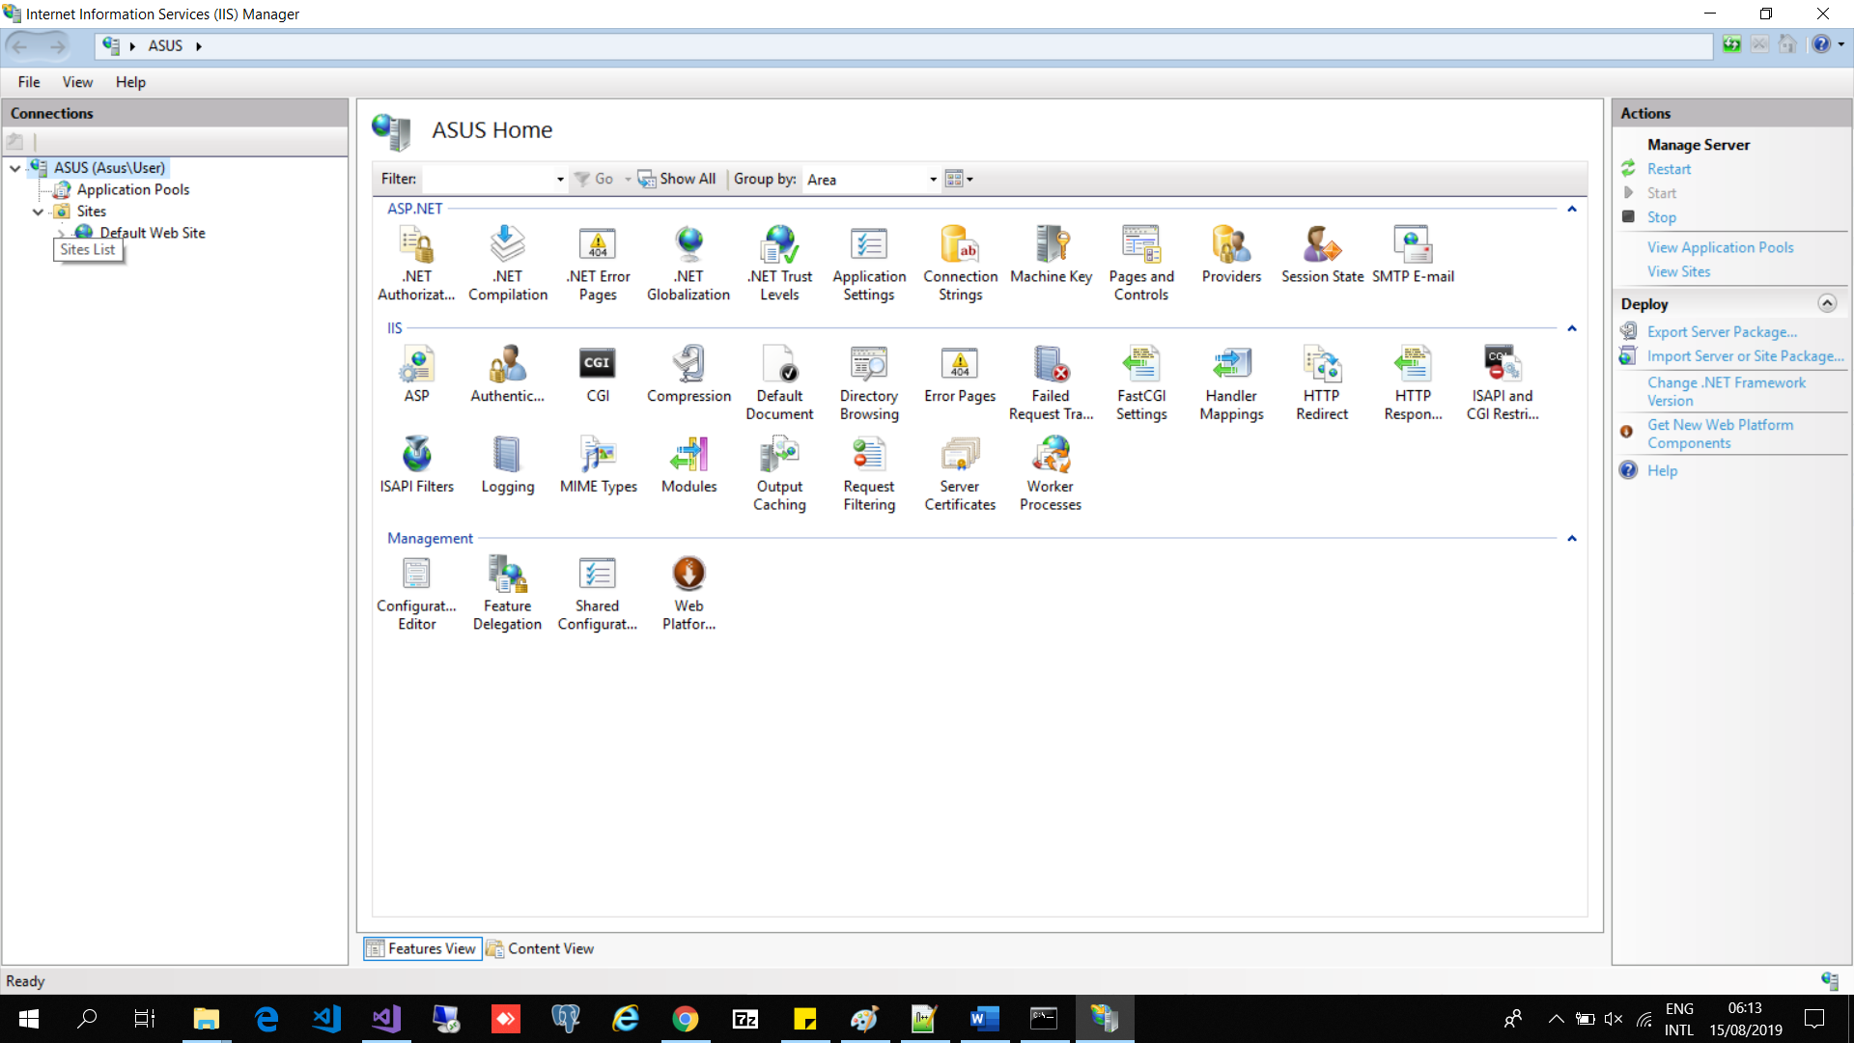

1. Right-click on sites and add Websites
2. Settings for eCRM:
   1. Sitename: Office
   2. Physical path: the current “wwwroot” directory that contains the eCRM folder

Example: “D:/inetpub/wwwroot”

* 1. Hostname: <http://office.jupem.xxx.gov.my>
  2. IP address: the provided Server IP, not the Public IP
  3. Create a new Application Pool and name it “ecrm”.

1. To get to eCRM, the hostname +”/ecrm”
2. Settings for Map:
   1. Sitename: Map
   2. Physical path: The current directory that contains CRM_Srv
   3. IP address: Hostname, and the Port number must be 5000
   4. Hostname: <http://office.jupem.xxx.gov.my>.

When the application site is launched, it should be <http://office.jupem.xxx.gov.my:5000>

* 1. Create a new Application Pool with these settings:
     1. Under the .NETClrVersion: Choose “No Managed Code”
     2. Name the Pool “map”.

1. Under the Office setting, under the IIS Section, double-click on Request-Filtering to open the sub menu
2. On the left-side of the panel, click on “Edit Feature Setting”.
3. Change the maximum allowed length to 3000000 (3GB).

Failure to change will result in large files unable to be uploaded into the web application folder

1. On the main panel, select “Browse” under the Browse Website section to test the website and connection.

### 6.1.5 Windows Schedular and Services

#### 6.1.5.1 Setting guide

1. Open Windows Scheduler:
   1. Go to the Search function and type “Task Scheduler” to access the scheduler immediately.
2. Select “Action” tab.
3. Click on “Import Task”.
4. Locate the .XML files in the GDPM folder to import the scheduled task.
5. On the Task Scheduler Library:
   1. Make sure there are these scheduled tasks:
      1. GDPM_start_server
      2. GDPM_server_check
      3. GDPM_spider
      4. GDPM_spider_retrieve
      5. GDPM_compute
      6. GDPM_cassini_updater (for Labuan server only)
      7. GDPM_ecosting
   2. Right click on each Tasks and select “Properties”
   3. In the General Tab, tick on these checkboxes:
      1. Run whether the user is logged on or not
      2. Run with highest privilege
      3. Hidden
      4. Configure for: Windows Server 2016 (or when applicable)
   4. In the Actions Tab:
      1. Ensure that the location is pointing towards the right folder

### 6.1.6 Integration & Webservices

|  |  |
| --- | --- |
| **List of Integration** | **Webservices** |
| SPAK |  |
| SPPK | In the web.config:   * Under the <connection strings>, labelled SPPK and SPPK2 |
| eCosting | As a web application, located in the GDPM folder, under GDPM_Ecosting |
| Spidernet | Credentials are stored in the PgSQL in the GDPM_Spiderweb table |
| Coordinate Transformative Service (SPAKLS) | Process:   1. The web application searches through the job file folder for evrscal json file 2. The system extracts the equipment serial (‘eqserial’) and outputs it to the view with the PathJupem link 3. The view will provide a button that links to the SPAKLS cert to verify the registered cert for the said device |

### 6.1.7 Servers IP & Hostname and Credentials

### 6.1.8 Remote Access

## 6.2 eCRM Field

### 6.2.1 Trimble SDK

### 6.2.2 GDAL

### 6.2.3.Net Framework

### 6.2.4 eCRM Field & License

### 6.2.5 Integration & Webservices

# 7. Application Workflow

## 7.1 eVRSCal

## 7.2 eCRM Field

## 7.3 Single Base

## 7.4 eCRM Office

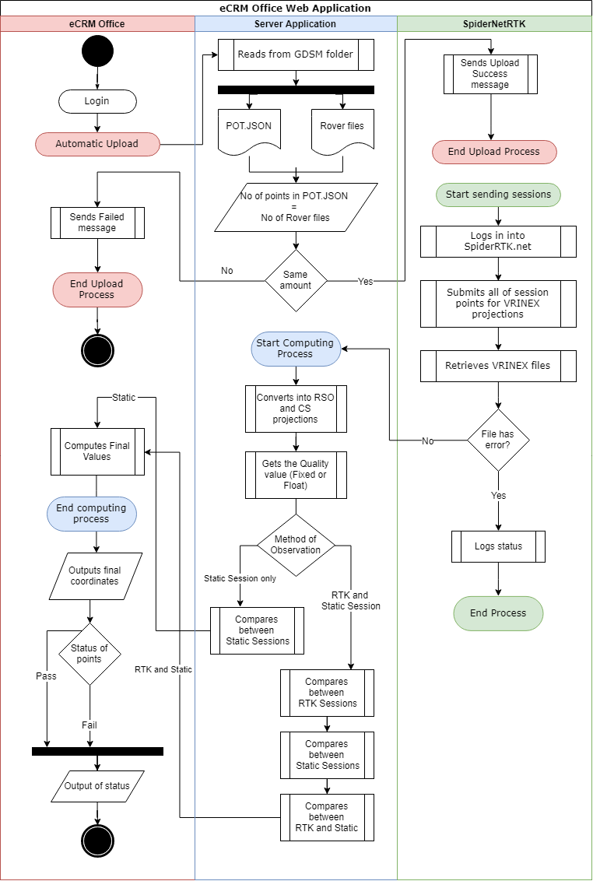

Figure 7.1: The workflow process of eCRM Office and the accompanying Server Application

### eCRM Office Workflow

1. User logins in to eCRM Office via eKadaster SSO login.
2. Upon login, user will be redirected to the Manual Upload page first.
3. User goes to the sidebar and clicks on **Main Dashboard** to view:
   1. Number of files at hand.
   2. Number of files passed.
   3. Number of files failed.
   4. Number of files in-progress or stalled.
   5. The list of files uploaded by the said user. KC however, views all files submitted by all of his Doers
4. User can view the contents of the job file by clicking on one of the files and clicks on **Details** to view contents.
5. The Job File details contains:
   1. Number of points passed or failed
   2. Files generated both by the Field and Office system
   3. eVRSCAL certificate
   4. Location of observed points on the map
   5. Images and attachments captured by the Pegawai
   6. Quick view of all the points and it’s method of observations
   7. Further drilled downs of the points to view individual sessions
   8. Computation method taken to produce the comparison projection values and whether it meets the tolerance level or not
6. Users can also view RINEX submission and retrieval logs in both the Job File details content or the main **RINEX log** page to generate an overall submission log and/or monthly log
7. The **Activity** page covers these lists:
   1. When the user logs in.
   2. Which files are submitted and when the files are uploaded.
   3. When the file is deleted.
   4. If the job file points have been resubmitted
   5. Which points have been deleted.
8. The Statistic summary page surmises the duration it takes to complete the computation of the files

### Automatic Uploading Workflow

1. eCRM Office upload process works in 2 parts:
   1. Web upload
   2. Server app validation
2. Web upload allows the User to upload the job file and gives messages if the server is responding and saves the file in a location that serves as a backup.
3. Server app validates the file by checking for:
   1. Naming convention i.e. “PUXXCRM_XXXX”
   2. GDSMPROJECT folder (generated by Field)
   3. POT.JSON and ROVER files

### Computation Workflow

1. Server application reads from Rover JSON files to populate into a local database. The naming convention follows the Rover name i.e. **Rover_XX_XX.d3**
2. The application reads from the **PostgreSQL** (Pgsql) database to get the session key ID of the CRM points and the User Spiderweb credentials
3. Submits all the session key with a unique transaction id (trnid) to SpiderwebRTK and awaits for results.
4. If successful, retrieves the session files and downloads into the AppFiles > tmp folder
5. GDPM_Compute will extract the .T02 files and convert it into RINEX files and renames it to Base naming convention i.e. Base_XX_XX.json
6. GDPM_Compute will run the baseline operation, where it will create a .d3 in the GDPMPROJECTS folder, and insert all of the observed coordinates in order to get the:
   1. Individual projection coordinates
   2. Mean values
   3. Variance and Co-variance values
   4. Quality of the observation
7. The if all the Base values covers the Rover observed projections, a baseline json file will be created; The Office web application will generate a Baseline reports for each session based on this json file.
8. The server application will update the GDPM_SESS and GDPM_CRM with the stated values.
9. GDPM_Compute will be called to run the stone function which calculates all individual session values to determine if the session is valid or not; The identifier is in the GDPM_SESS ‘isvalid’ column will state it as TRUE or FALSE with an updated Date_Compute datetime of said computation.
10. GDPM_Compute will again run the stone function to update GDPM_CRM table on both the points with the averaged session values based on methods of observation and finally update the final projected coordinate value of the points; This will be updated in the obsmethod row where the value is NULL.

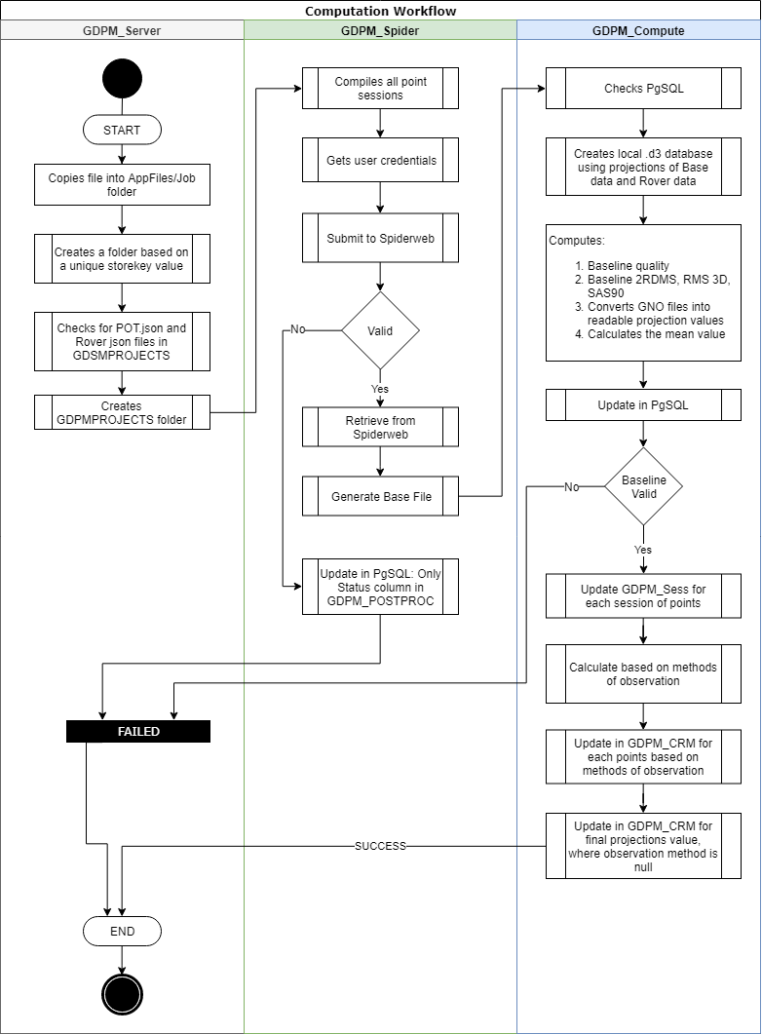

### eCosting Workflow

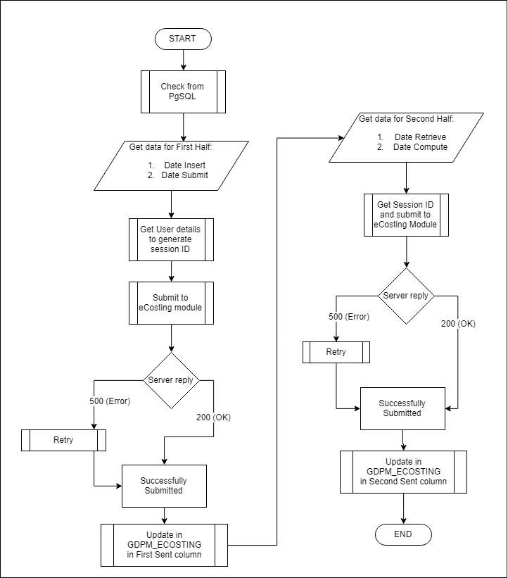

## 7.5 GNSS Calibration